Guidance for Topic 6 DQ 1
- Drag down the formula in C4 until you hit roll 1,000. Do the same for D4, but this time, you have to drag down the formula until roll 4,000.
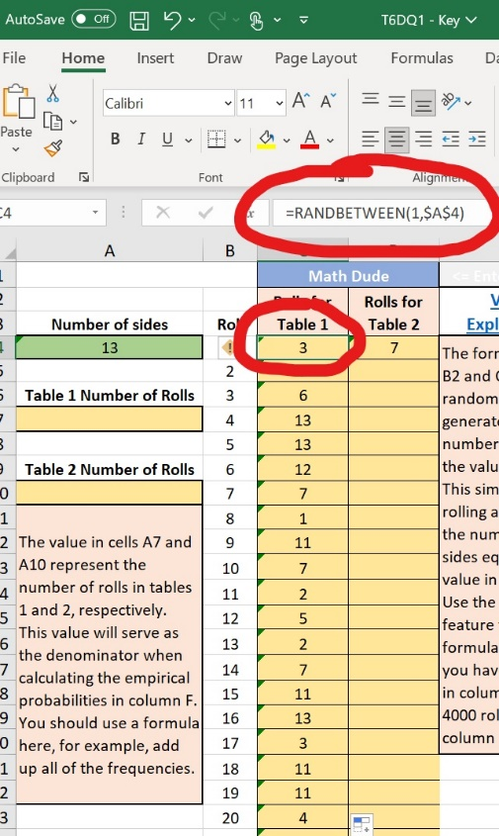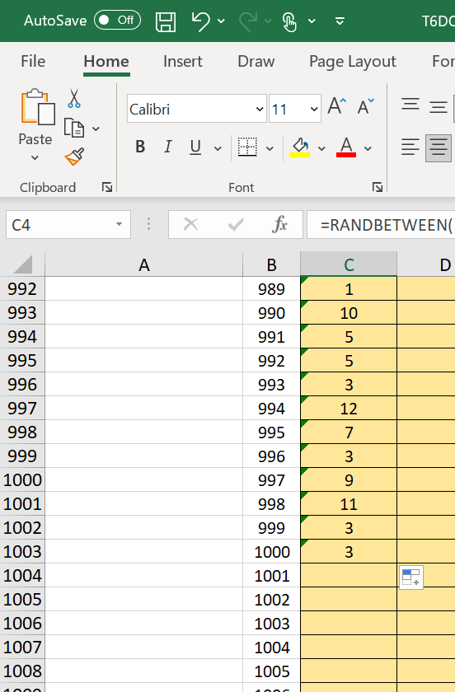

- Enter the total number of rolls in A7 and A10, which in this case is 1,000 for A7 and 4,000 for A10.

- Enter a formula in H4 and drag down the formula in column H. Make sure to use $A$7 so that your choice of A& is fixed.

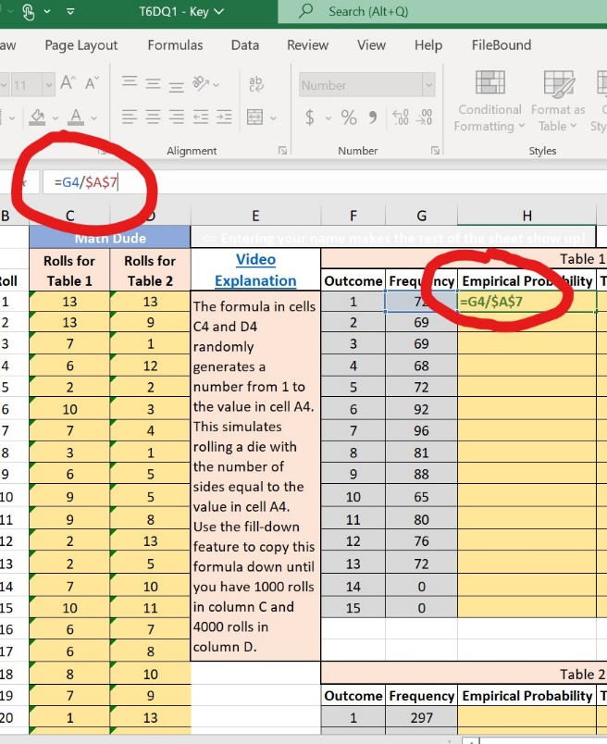

- Do the similar thing for I4. Make sure to use $A$4 so that your choice of A4 is fixed.

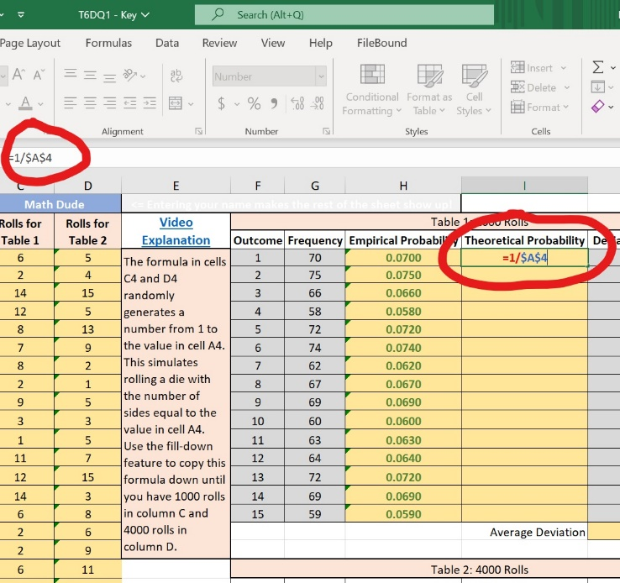

- Use =average() in J19.

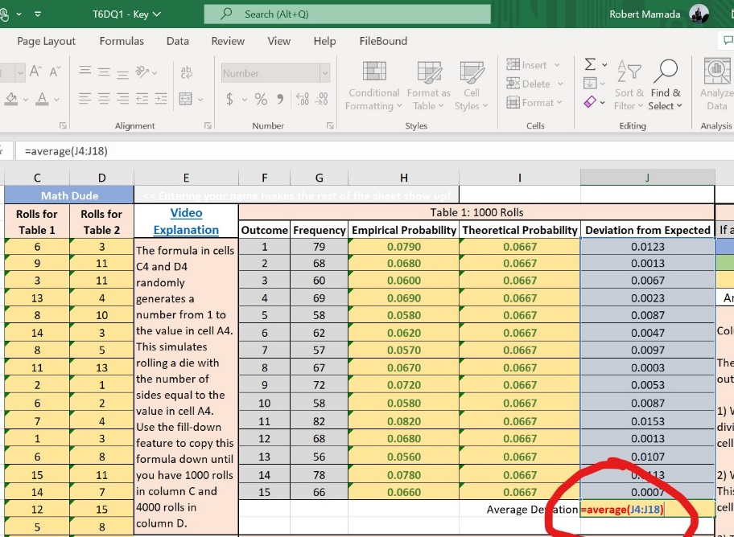

- Repeat the procedure mentioned above for Table 2.

- Type something and hit enter in the blue cells and you will get different numbers each time for J19 and J38. Record these numbers in the table from rows 42 to 46. Alternatively, every time you enter a number and hit enter in the green table, the numbers in J19 and J38 change. Record these numbers.

- Don’t forget to write your response in the blue space below the big arrow.

